Kings College Baseball Development

Backstop Fencing Requirements

Main Backstop Fence 7m high
- 21m run of fencing in 3 sections at 135o from each other
- 7m high.
- Twin Wire 200 x 50 heavy duty 868 mesh construction
- Posts to be dug in

Backstop Wing Fence
- 2 runs of fencing 10m each (20m total)
- From each end of Main Backstop fence
- 1.4m high
- Twin Wire 200 x 50 heavy duty 868 mesh construction

Spectator Fencing
- 2 runs of fencing from each end of Backstop Wing Fence
- 20m each (40m total)
- 1.2m high
- with a solid top bar of 48mm diameter.
- This fencing and rail is designed for spectators to stand at and lean on, with safety in mind.

Access Gates
- Two single swing gates
- One in each run of spectator fencing, at 1.2m high
- to provide access onto diamond.

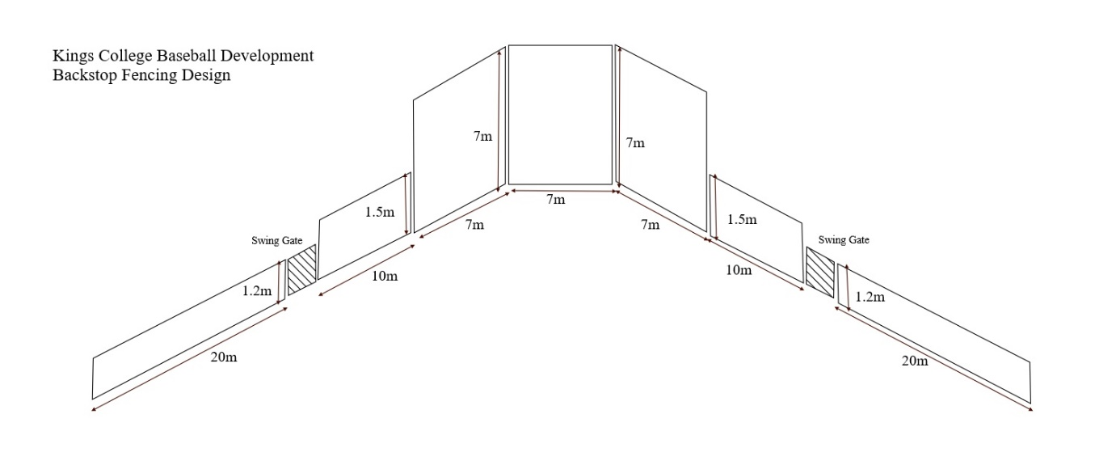

Quote Requirements
- Cost to include materials and labour for this to be completed in accordance with manufacturer’s recommendations.
- There is some flexibility on actual dimensions if they fit standard panel sizes better

